**Name: Nagma Nishat**

**Cloud Provider Google Compute Engine:**

**Sign up for free trail**



**Create instance**

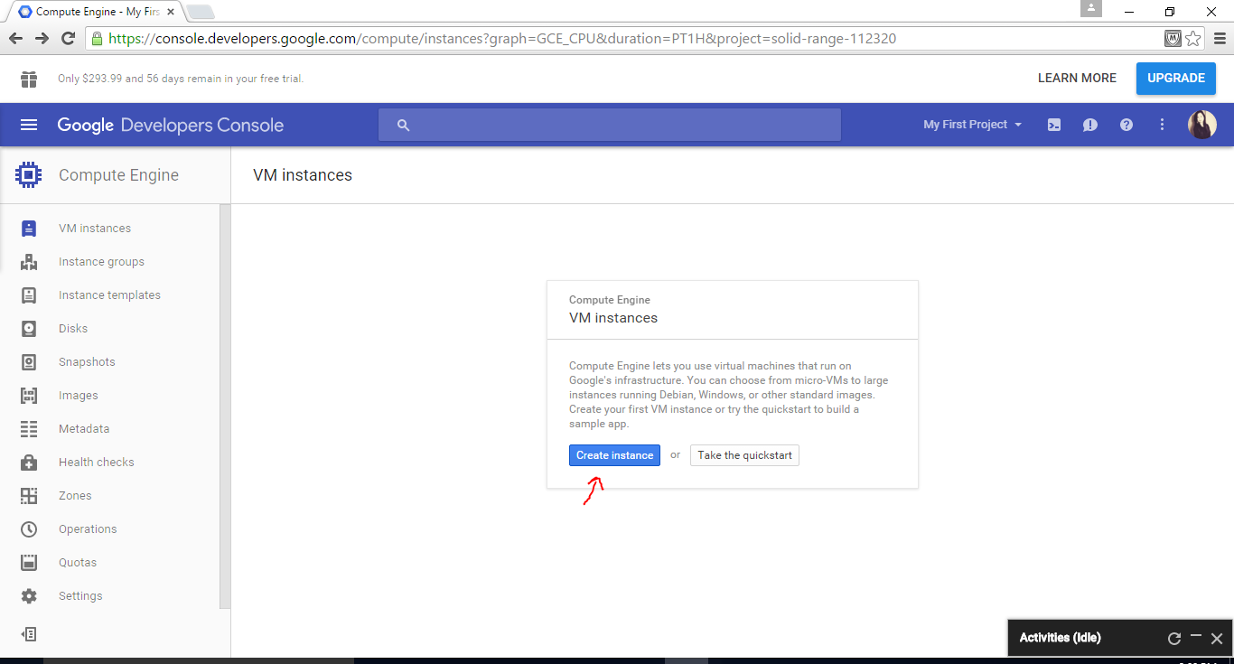

**Machine type:**

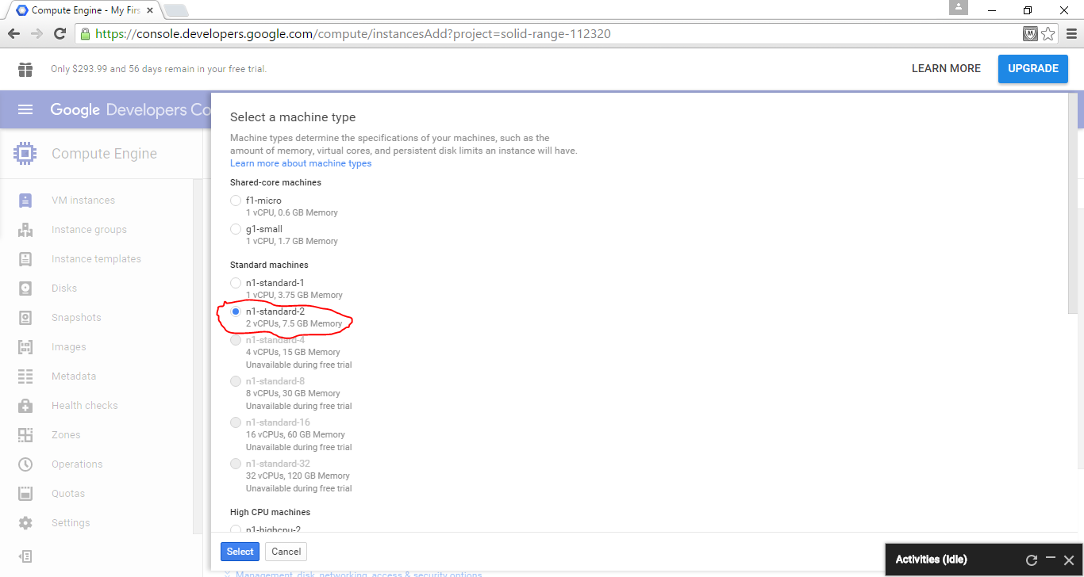

**Boot disk:**

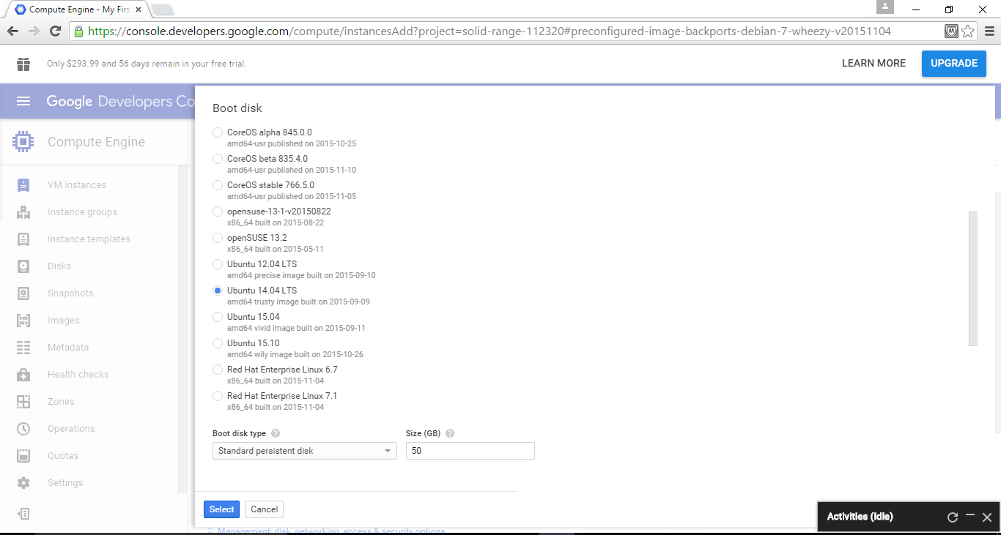

Create instance

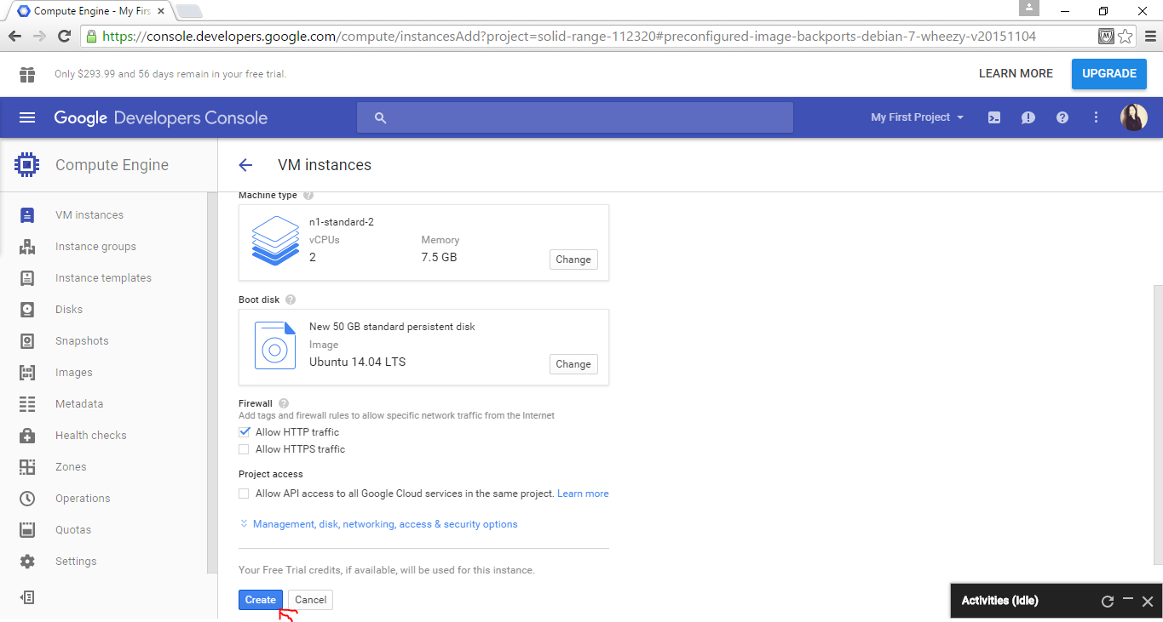

Instance created:

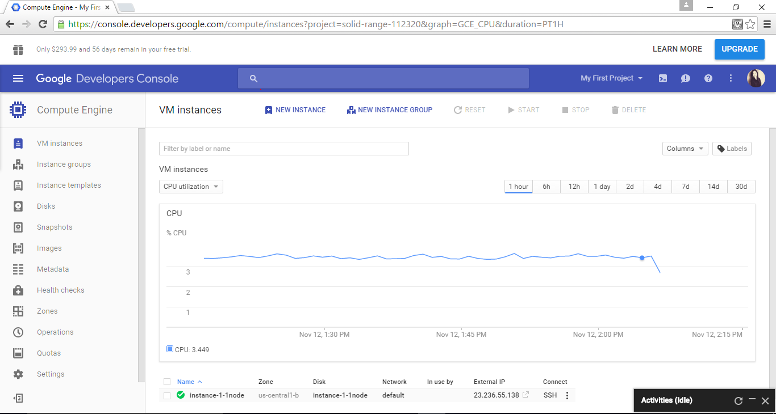

Connect using SSH

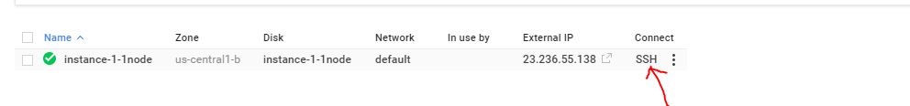

**Steps to install Cassandra 3.0.0**

**1. Change root password**  
 sudo passwd root  
 yourpw  
 su  
 yourpw

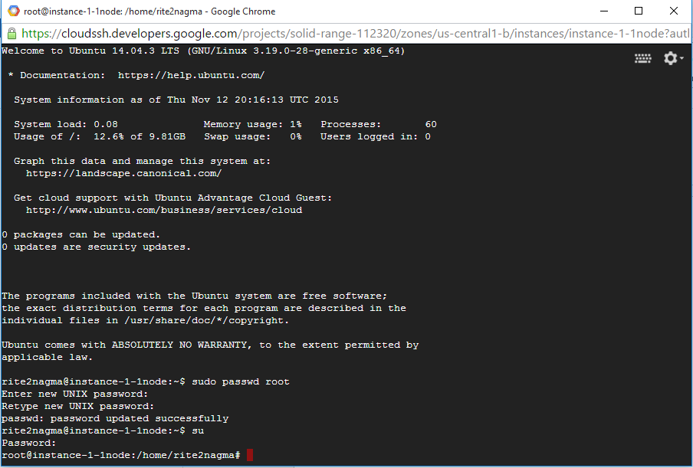

**2. Install Oracle Java 8 in Ubuntu**   
sudo add-apt-repository ppa:webupd8team/java

  
sudo apt-get update

  
sudo apt-get install oracle-java8-installer



**3. Set Java environment variables**

sudo apt-get install oracle-java8-set-default

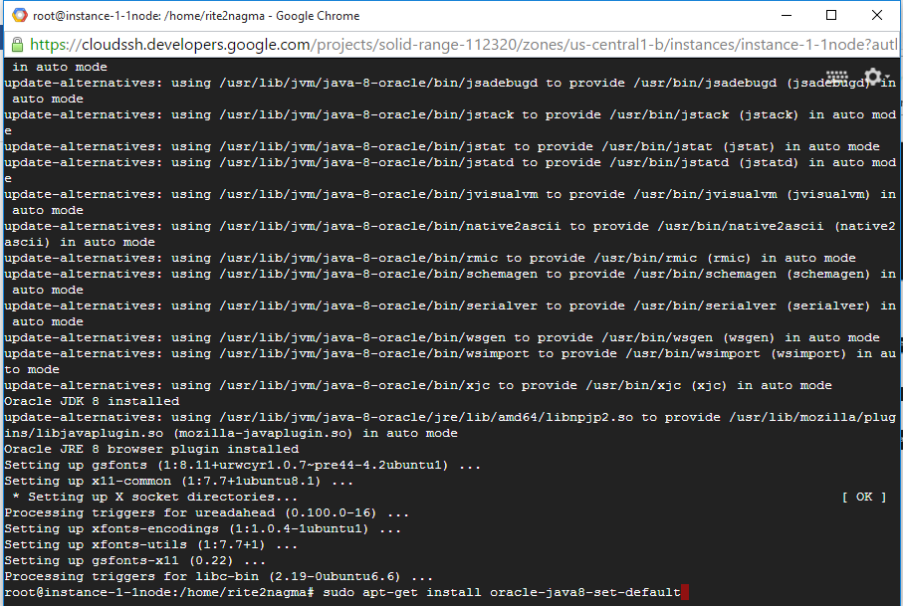

sudo apt-get update

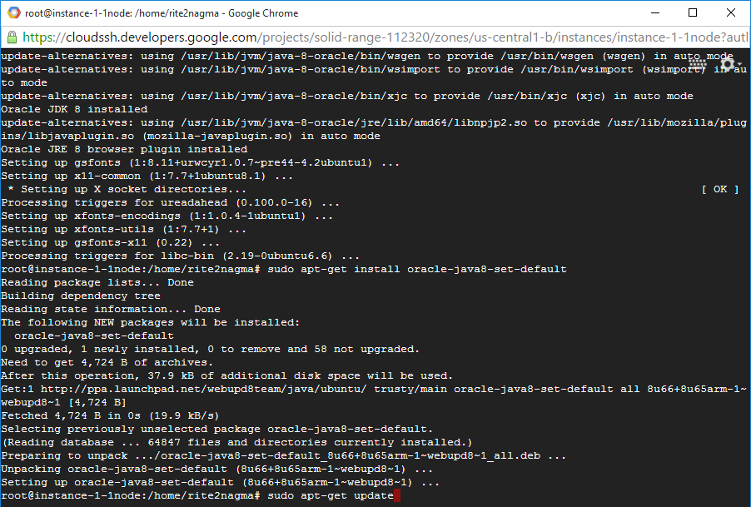

**4. Install cassandra**

mkdir /usr/local/cassandra

cd /usr/local/cassandra

wget <http://apache.cs.utah.edu/cassandra/3.0.0/apache-cassandra-3.0.0-bin.tar.gz>

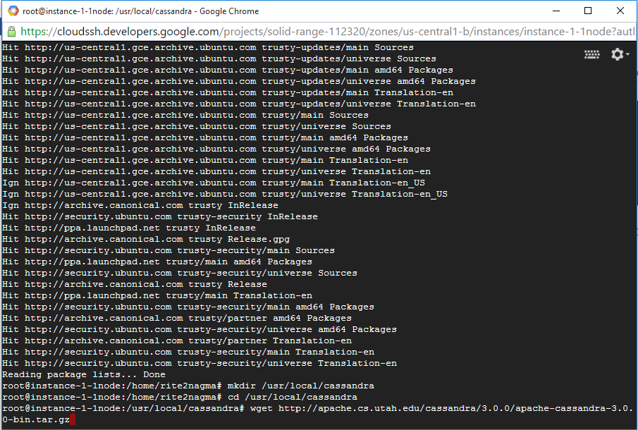

tar xvfz apache-cassandra-3.0.0-bin.tar.gz

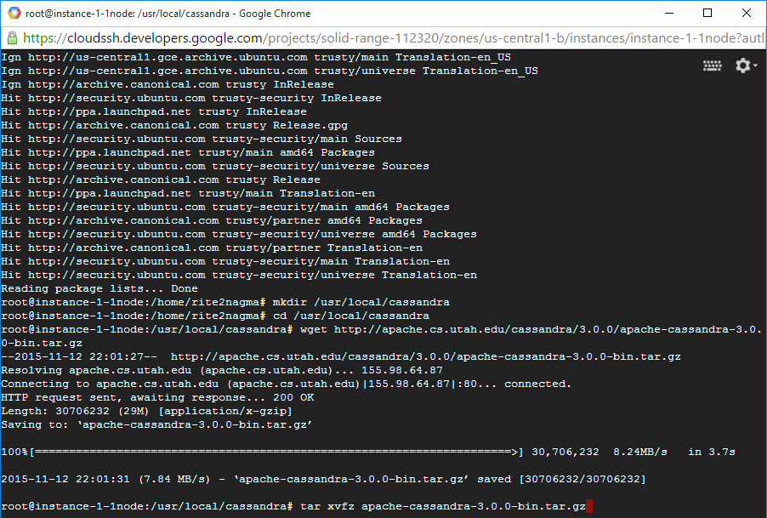

**5. check IP addresse of instances**

ifconfig

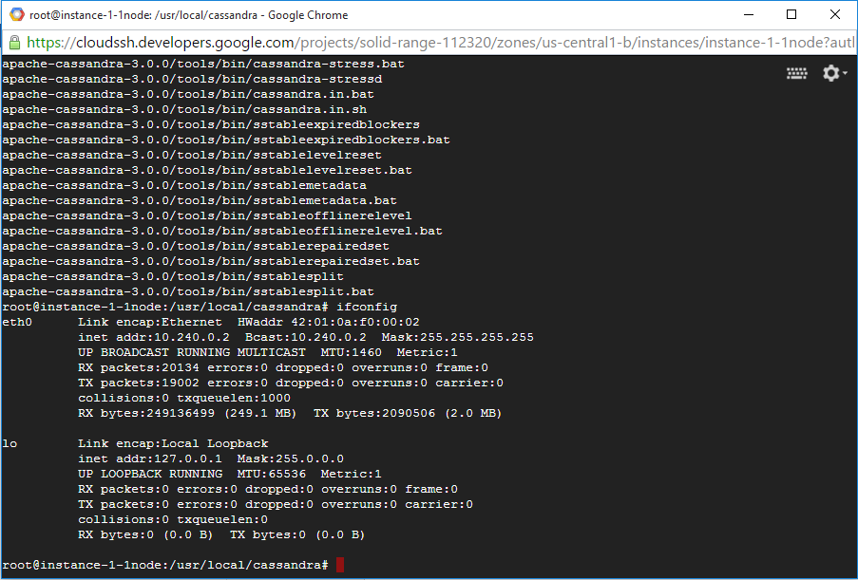

IP: 10.240.0.2

**6. Make a backup for all nodes**

cp apache-cassandra-3.0.0/conf/cassandra.yaml apache-cassandra-3.0.0/conf/cassandra.yaml_bak



**7. Modify configuration for all nodes.**

nano apache-cassandra-3.0.0/conf/cassandra.yaml

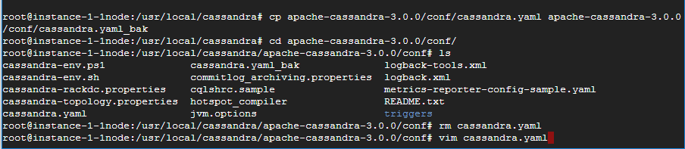

*Note:*

*Find listen_address: and seeds: (Ctrl+W) and modify it*

*listen_address should be own IP of each instance.*

listen_address: 10.240.0.2

seeds:  "10.240.0.2"  
rpc_address: 0.0.0.0  
broadcast_rpc_address: 1.2.3.4

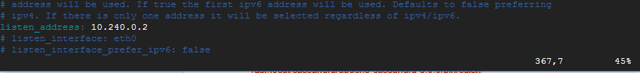

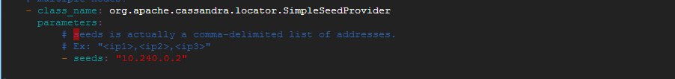

**8. Excute cassandra**

/usr/local/cassandra/apache-cassandra-3.0.0/bin/cassandra



/usr/local/cassandra/apache-cassandra-3.0.0/bin/nodetool -h localhost -p 7199 status

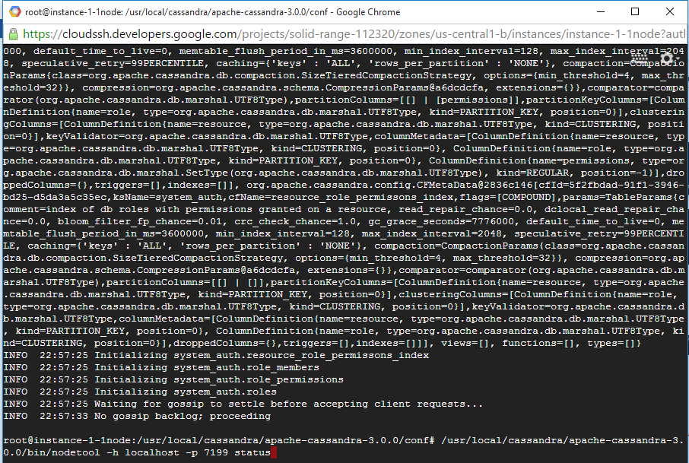

/usr/local/cassandra/apache-cassandra-3.0.0/bin/cqlsh

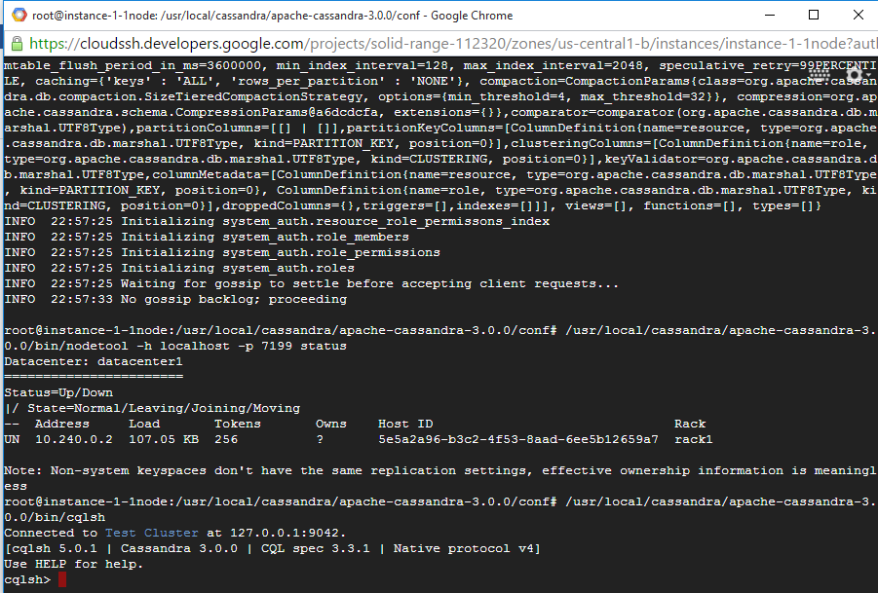

**9. Create keyspace and table for YCSB benchmark**

CREATE KEYSPACE usertable WITH REPLICATION = { 'class' : 'SimpleStrategy', 'replication_factor' : 3};

use usertable;

CREATE TABLE usertable.data ( key blob, column1 text, value blob, PRIMARY KEY (key, column1)) WITH COMPACT STORAGE AND CLUSTERING ORDER BY (column1 ASC);

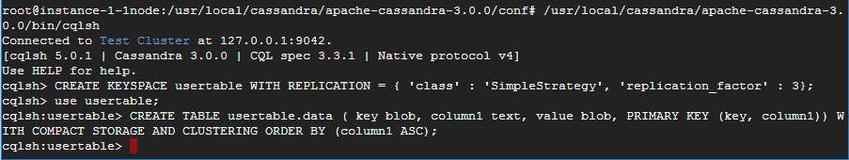

describe table data;

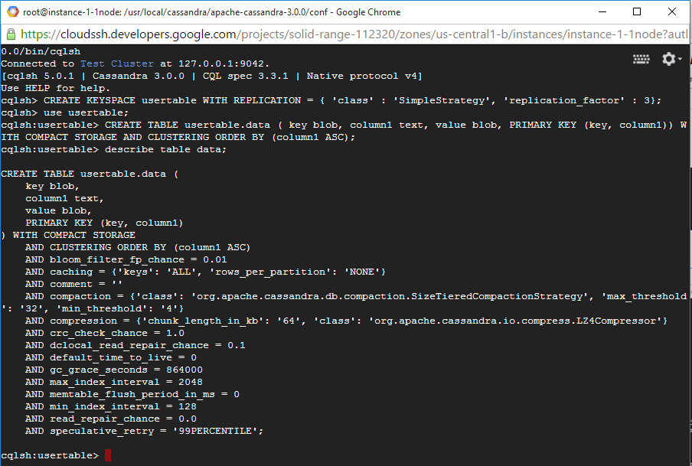

**Steps to install YCSB and benchmark Cassandra:**

1. **Create new instance for YCSB**

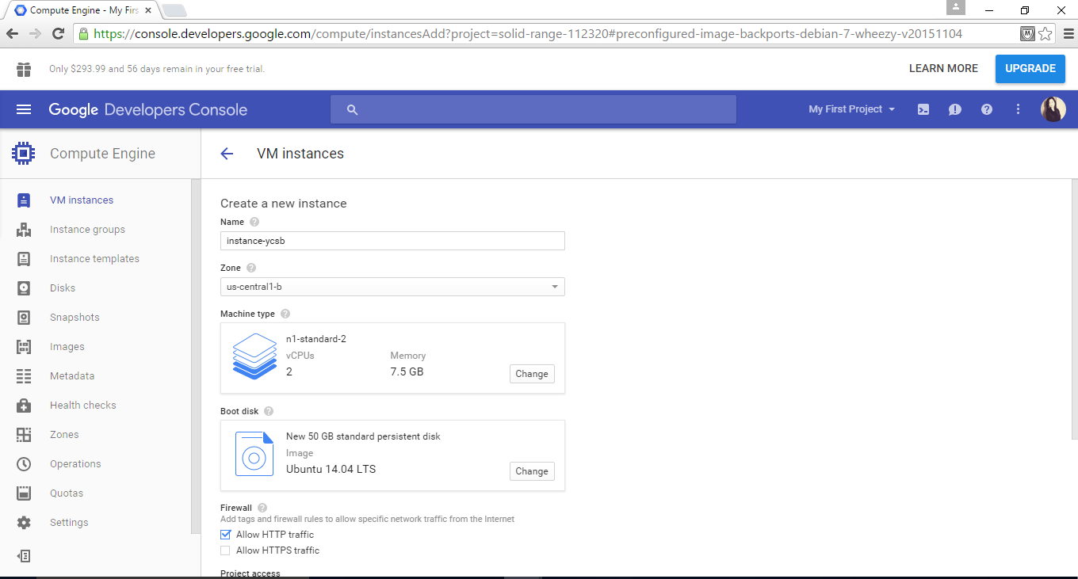

**2.Connect through SSH**

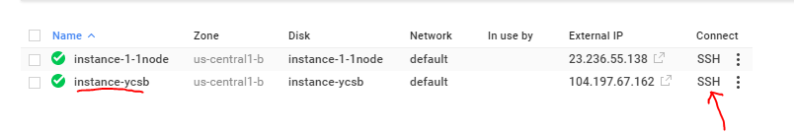

**3. Change root password**  
sudo passwd root  
yourpw  
su  
yourpw

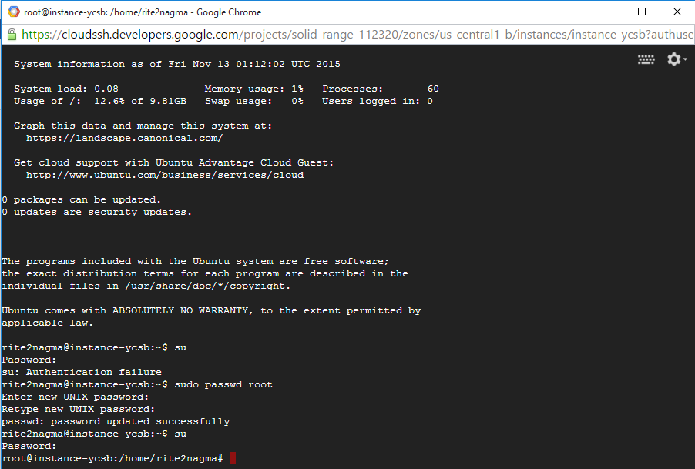  
**4. Install Oracle Java 8 in Ubuntu**   
sudo add-apt-repository ppa:webupd8team/java  
sudo apt-get update  
sudo apt-get install oracle-java8-installer

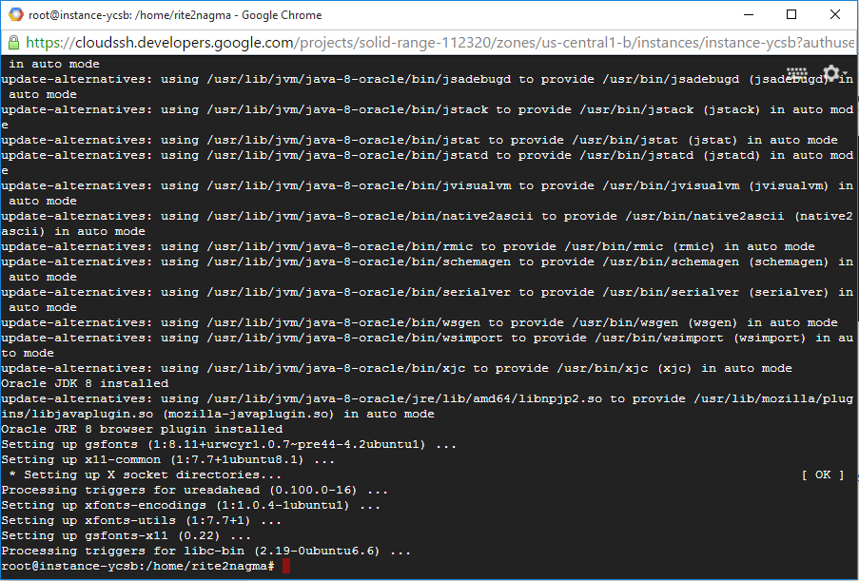

**5. Set Java environment variables**

sudo apt-get install oracle-java8-set-default

sudo apt-get update

**6. Install YCSB**

curl -O --location <https://github.com/brianfrankcooper/YCSB/releases/download/0.4.0/ycsb-0.4.0.tar.gz>

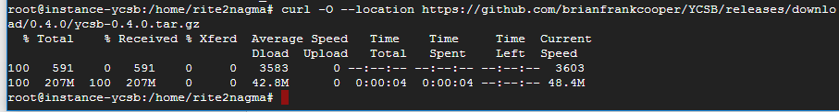

tar xfvz ycsb-0.4.0.tar.gz



cd ycsb-0.4.0

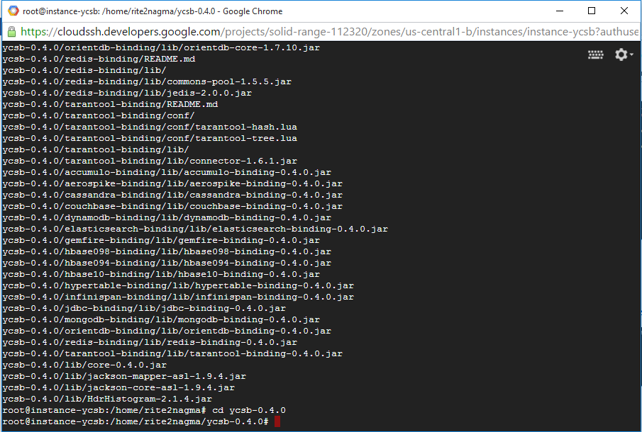

**7. Create workload files in workloads folder**

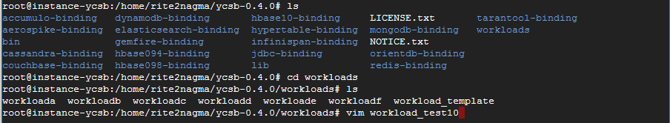

vim workload_test10  
  
-------------------------------------------------------------  
recordcount=214748  
operationcount=100000  
workload=com.yahoo.ycsb.workloads.CoreWorkload  
readallfields=true  
readproportion=0.5435  
updateproportion=0.4565  
scanproportion=0  
insertproportion=0  
requestdistribution=zipfian

------------------------------------------------------------

vim workload_test40  
  
-------------------------------------------------------------  
recordcount=536871  
operationcount=400000  
workload=com.yahoo.ycsb.workloads.CoreWorkload  
readallfields=true  
readproportion=0.5435  
updateproportion=0.4565  
scanproportion=0  
insertproportion=0  
requestdistribution=zipfian

------------------------------------------------------------

vim workload_test320  
  
-------------------------------------------------------------  
recordcount=3543348  
operationcount=3200000  
workload=com.yahoo.ycsb.workloads.CoreWorkload  
readallfields=true  
readproportion=0.5435  
updateproportion=0.4565  
scanproportion=0  
insertproportion=0  
requestdistribution=zipfian

------------------------------------------------------------

vim workload_test640

-------------------------------------------------------------  
recordcount=6120328  
operationcount=6400000  
workload=com.yahoo.ycsb.workloads.CoreWorkload  
readallfields=true  
readproportion=0.5435  
updateproportion=0.4565  
scanproportion=0  
insertproportion=0  
requestdistribution=zipfian

------------------------------------------------------------  
  
vim workload_test1200  
  
------------------------------------------------------------  
recordcount=10630044  
operationcount=12000000  
workload=com.yahoo.ycsb.workloads.CoreWorkload  
readallfields=true  
readproportion=0.5435  
updateproportion=0.4565  
scanproportion=0  
insertproportion=0  
requestdistribution=zipfian  
------------------------------------------------------------

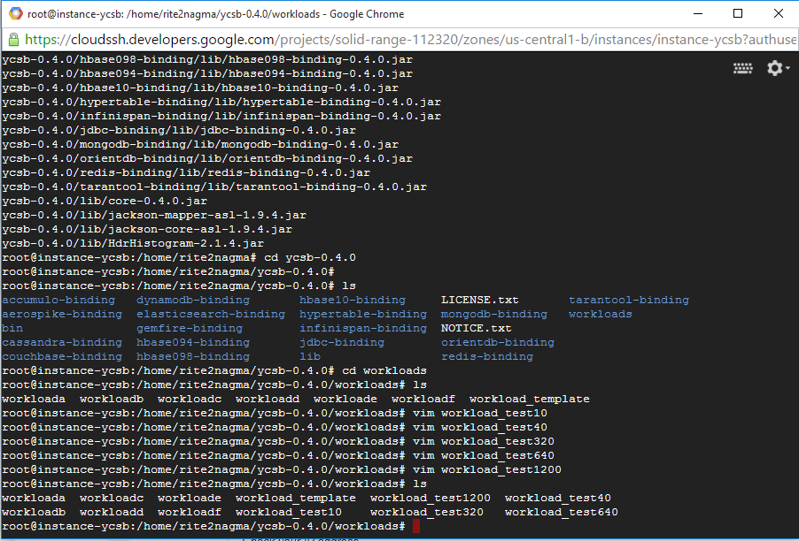

**8. Create a folder for results**

mkdir results_Cassandra

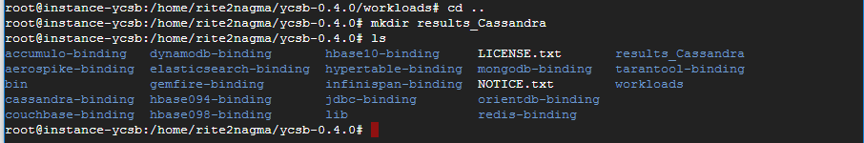

*//Note: benchmark for 10 concurrent users*

**9. Load data**

./bin/ycsb load cassandra-10 -P workloads/workload_test10 -p hosts=10.240.0.2 -threads 10 -p columnfamily=data -s > results_Cassandra/load_10



*Note:*

*Check your IP address and run just one commend for each experiment.*

**10. Run benchmark**

./bin/ycsb run cassandra-10 -P workloads/workload_test10 -p hosts=10.240.0.2 -threads 10 -p columnfamily=data -s > results_Cassandra/run_10

*Note:*

*Check your IP address*

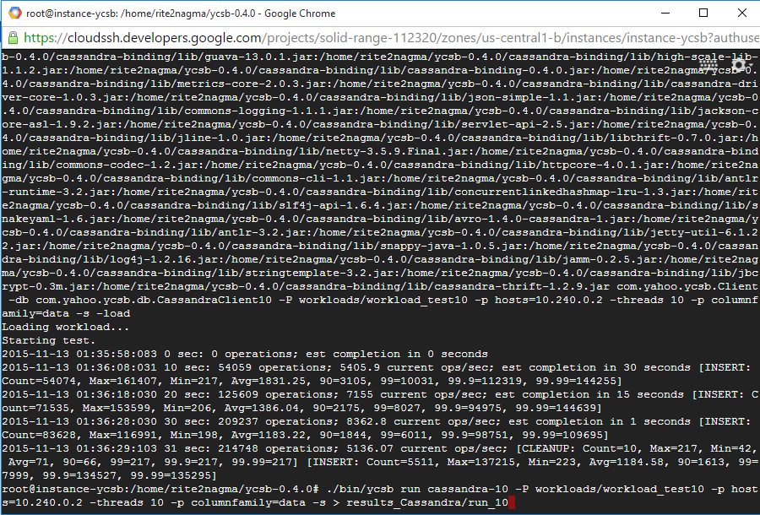

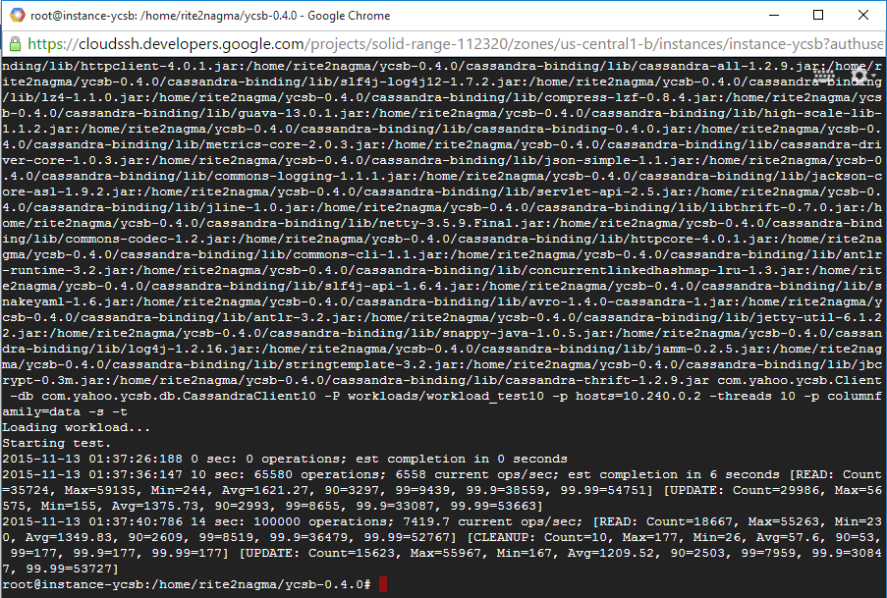

**load_10 and run_10 files are generated in directory results_Cassandra**



**Load_10 file**

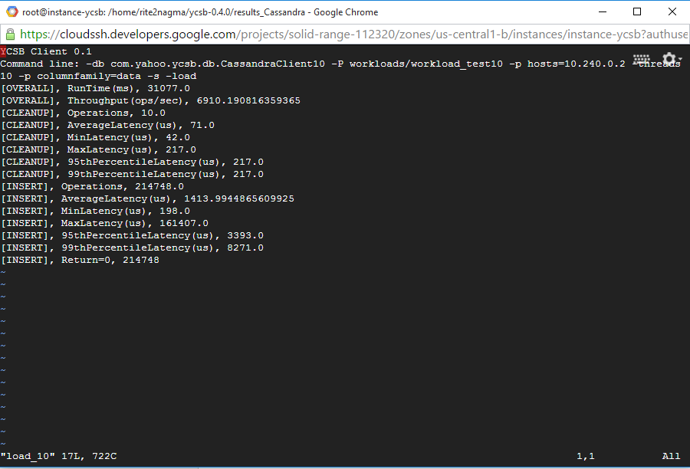

**Run_10 file**

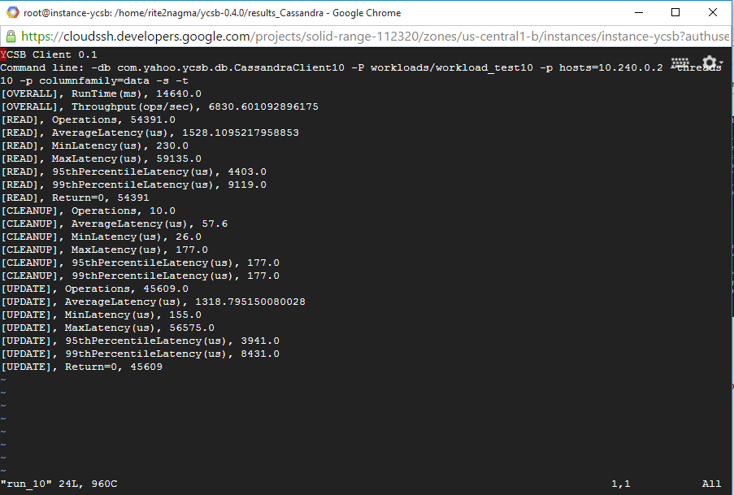

**11. Clean loaded data for next benchmark**

/usr/local/cassandra/apache-cassandra-3.0.0/bin/cqlsh

drop table usertable.data;  
CREATE TABLE usertable.data ( key blob, column1 text, value blob, PRIMARY KEY (key, column1)) WITH COMPACT STORAGE AND CLUSTERING ORDER BY (column1 ASC);

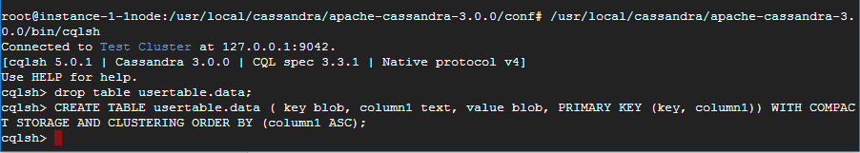

**11. Repeat the above steps for benchmark with different configurations.**

//Note: benchmark for 40 concurrent users

./bin/ycsb load cassandra-10 -P workloads/workload_test40 -p hosts=10.240.0.2 -threads 40 -p columnfamily=data -s > results_Cassandra/load_40

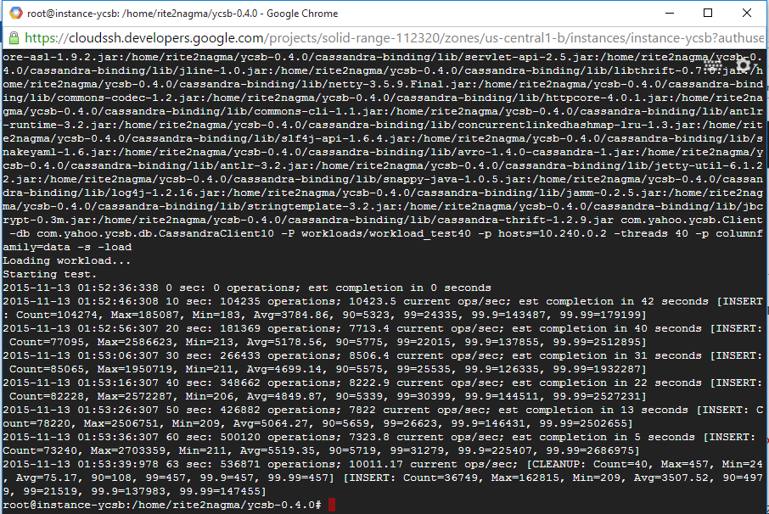

./bin/ycsb run cassandra-10 -P workloads/workload_test40 -p hosts=10.240.0.2 -threads 40 -p columnfamily=data -s > results_Cassandra/run_40

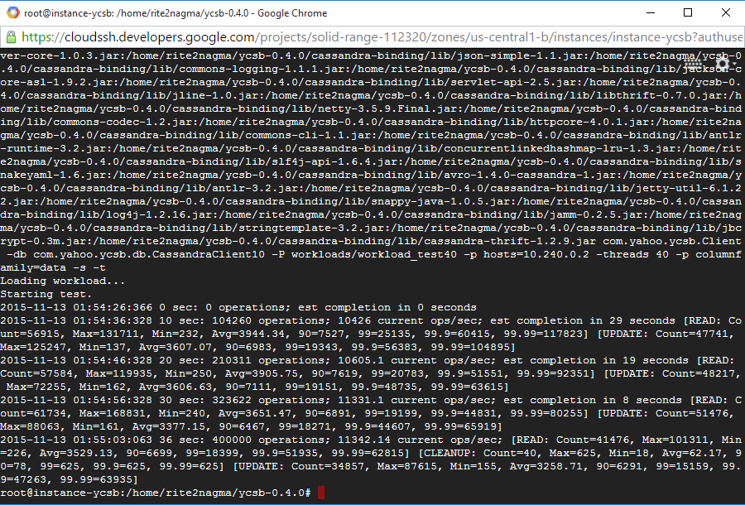

**Load_40 and run_40 files generated:**

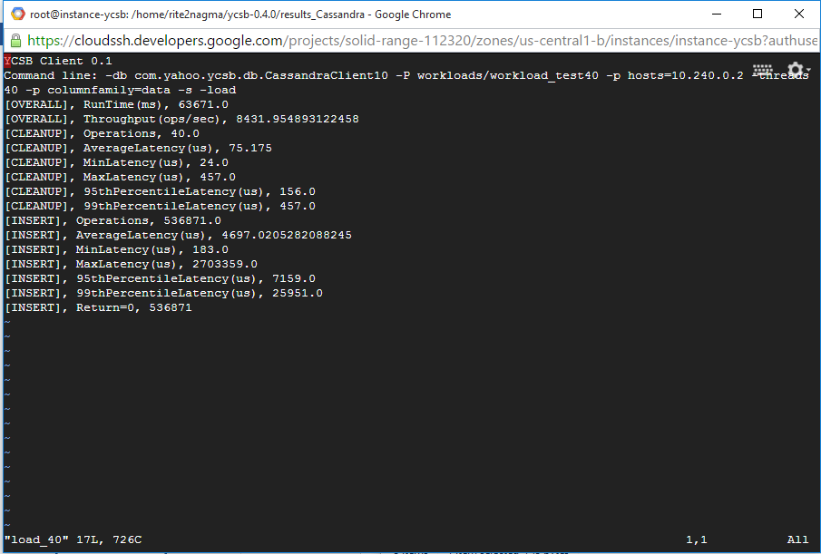

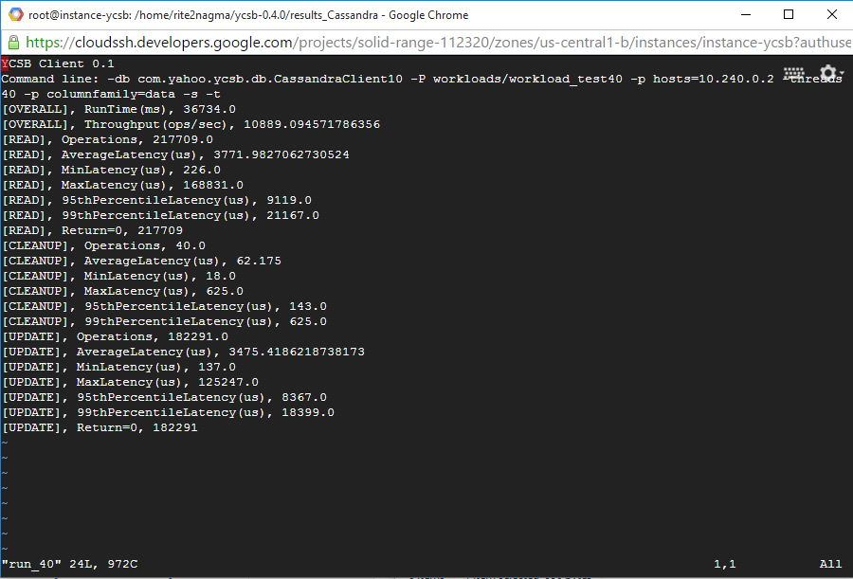

**Clean loaded data for next benchmark**

drop table usertable.data;  
CREATE TABLE usertable.data ( key blob, column1 text, value blob, PRIMARY KEY (key, column1)) WITH COMPACT STORAGE AND CLUSTERING ORDER BY (column1 ASC);

//Note: benchmark for 320 concurrent users

./bin/ycsb load cassandra-10 -P workloads/workload_test320 -p hosts=10.240.0.2 -threads 320 -p columnfamily=data -s > results_Cassandra/load_320

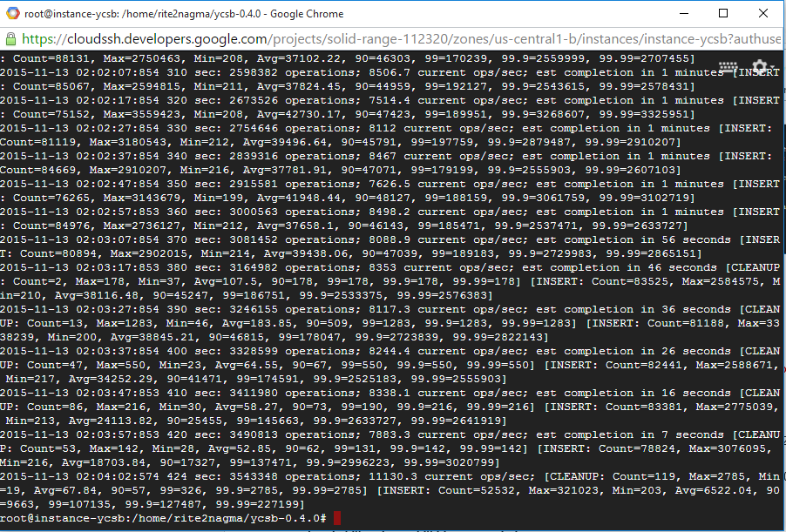

./bin/ycsb run cassandra-10 -P workloads/workload_test320 -p hosts=10.240.0.2 -threads 320 -p columnfamily=data -s > results_Cassandra/run_320

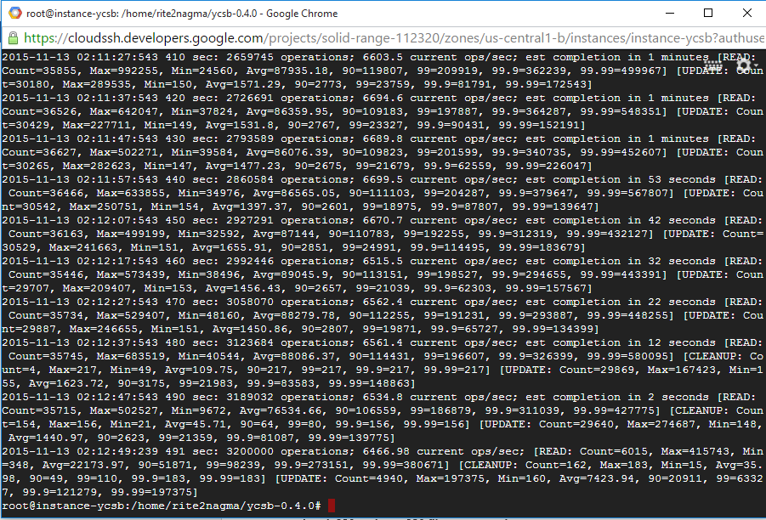

**Load_320 and run_320 files generated:**

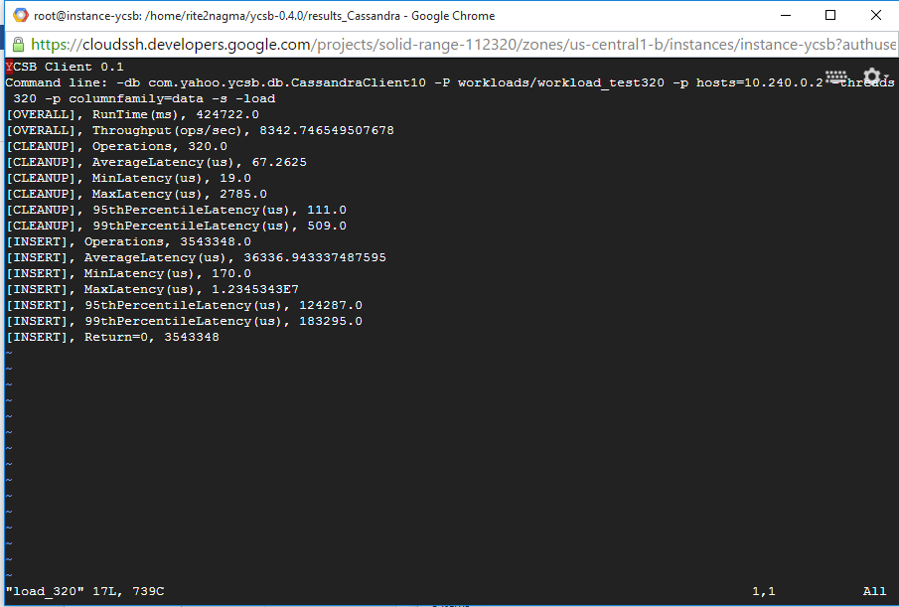

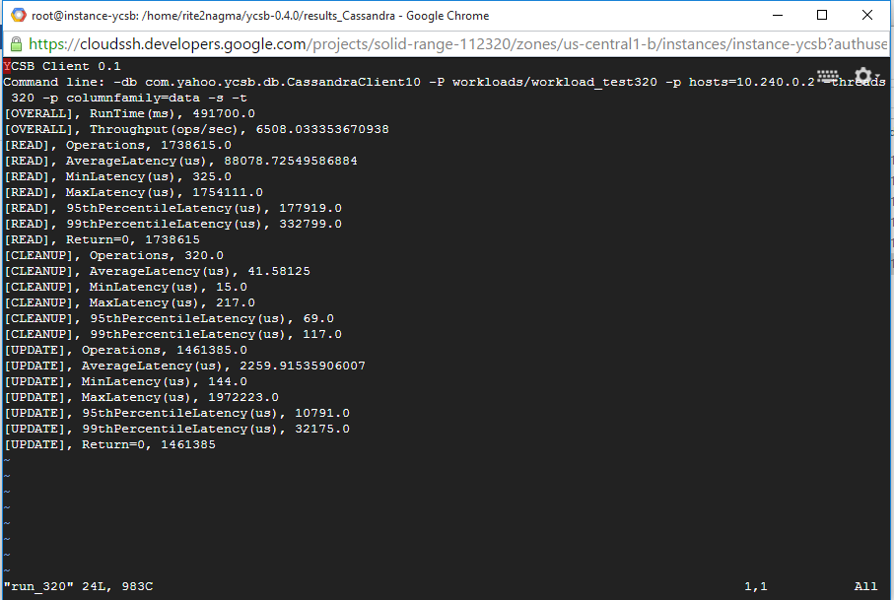

**Clean loaded data for next benchmark**

drop table usertable.data;  
CREATE TABLE usertable.data ( key blob, column1 text, value blob, PRIMARY KEY (key, column1)) WITH COMPACT STORAGE AND CLUSTERING ORDER BY (column1 ASC);

//Note: benchmark for 640 concurrent users

./bin/ycsb load cassandra-10 -P workloads/workload_test640 -p hosts=10.240.0.2 -threads 640 -p columnfamily=data -s > results_Cassandra/load_640

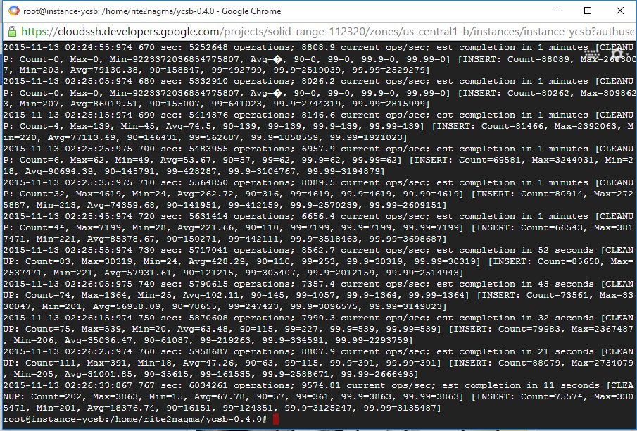

./bin/ycsb run cassandra-10 -P workloads/workload_test640 -p hosts=10.240.0.2 -threads 640 -p columnfamily=data -s > results_Cassandra/run_640

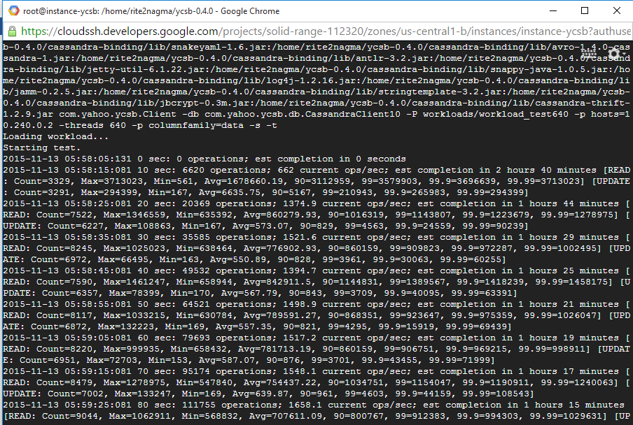

*Benchmark for 640 users taking more time to run. So we cancel the process.*

**Clean loaded data for next benchmark**

drop table usertable.data;  
CREATE TABLE usertable.data ( key blob, column1 text, value blob, PRIMARY KEY (key, column1)) WITH COMPACT STORAGE AND CLUSTERING ORDER BY (column1 ASC);

**Steps to Benchmark Cassandra with 3 nodes:**

**Create 3 instances for running 3 nodes:**

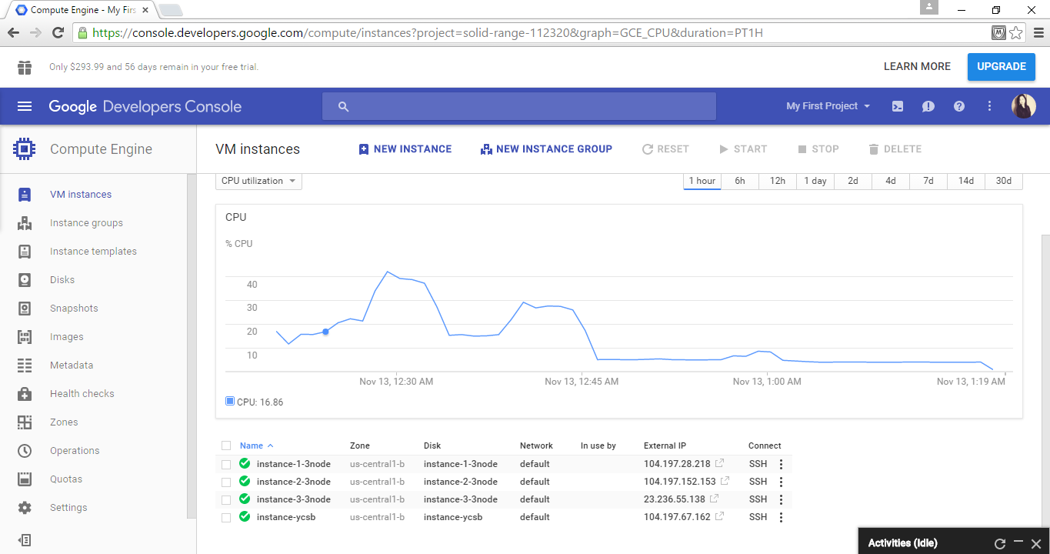

Install Java and Cassandra on all the three instances (follow the same steps as done for 1 node above)

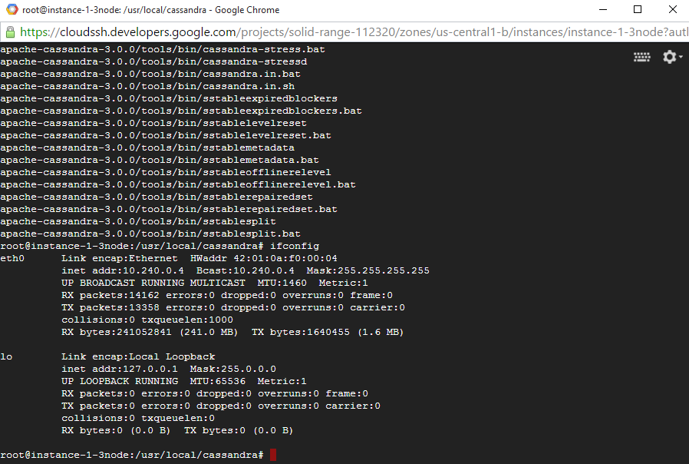

IP for 1st node: 10.240.0.4

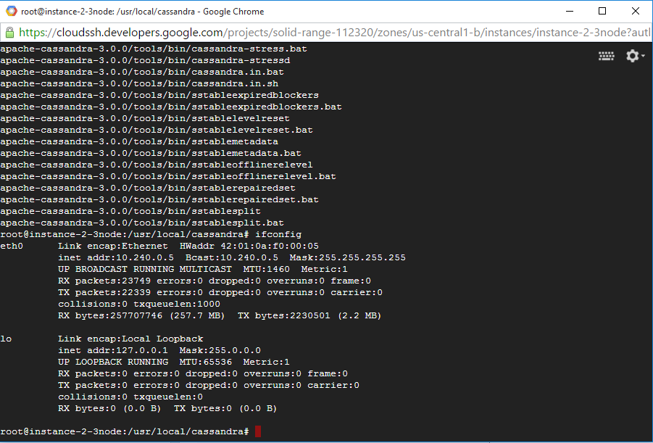

IP for 2nd node: 10.240.0.5

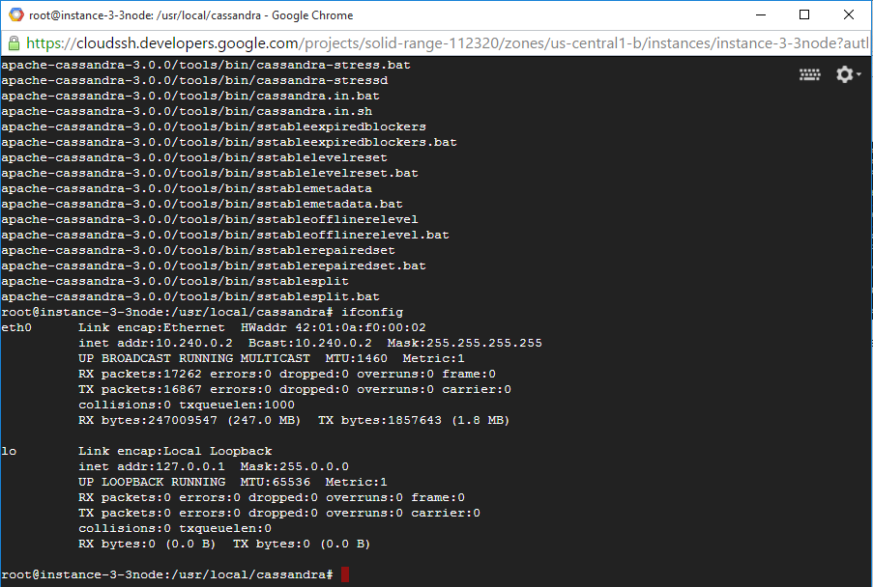

IP 3rd node : 10.240.0.2

Open file cassandra.yaml in all the three nodes Find listen_address: and seeds: (Ctrl+W) and modify it.

listen_address should be own IP of each instance.

Seeds should be IP of all the three nodes i.e. “10.240.0.4, 10.240.0.5, 10.240.0.2”

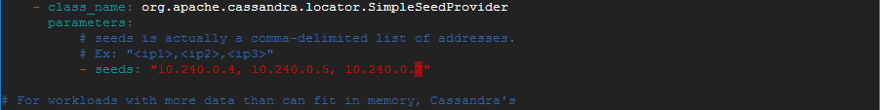

Cassandra installed for node 1:

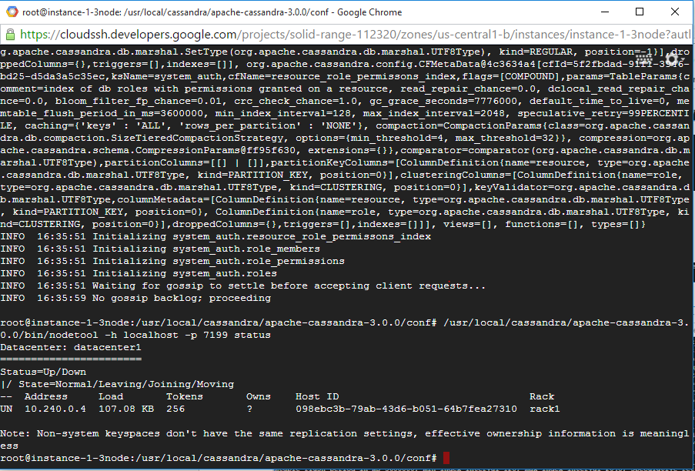

Cassandra installed for node 2:

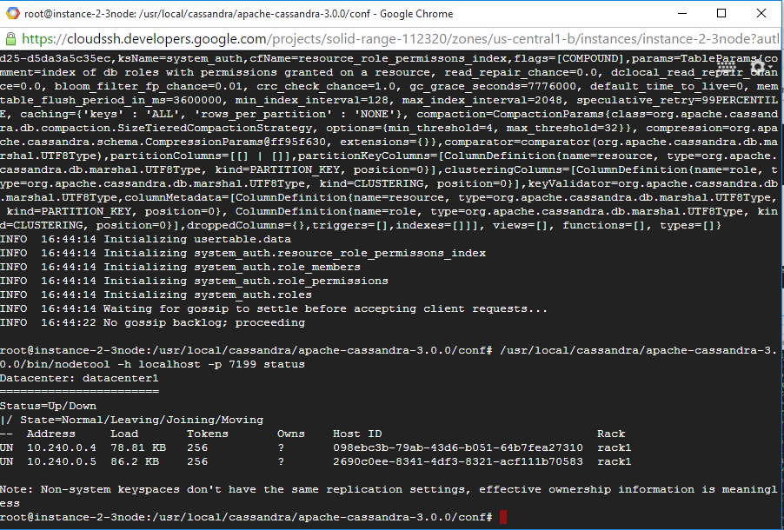

Cassandra installed for node 3:

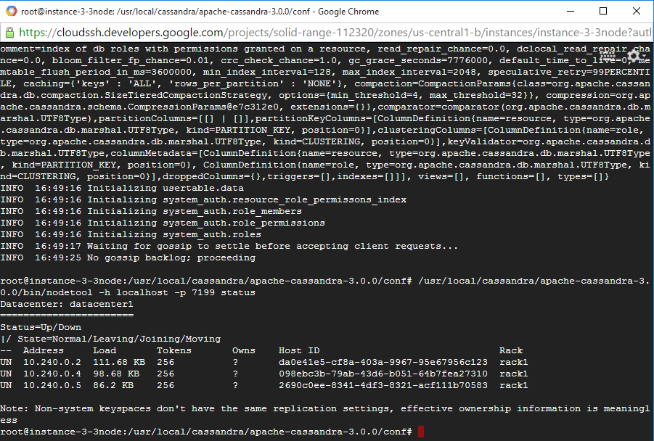

**Run YCSB and benchmark Cassandra for 3 node:**

**Load data**

./bin/ycsb load cassandra-10 -P workloads/workload_test10 -p hosts=10.240.0.4 -threads 10 -p columnfamily=data -s > results_Cassandra/load_10

**Load_10 file generated:**

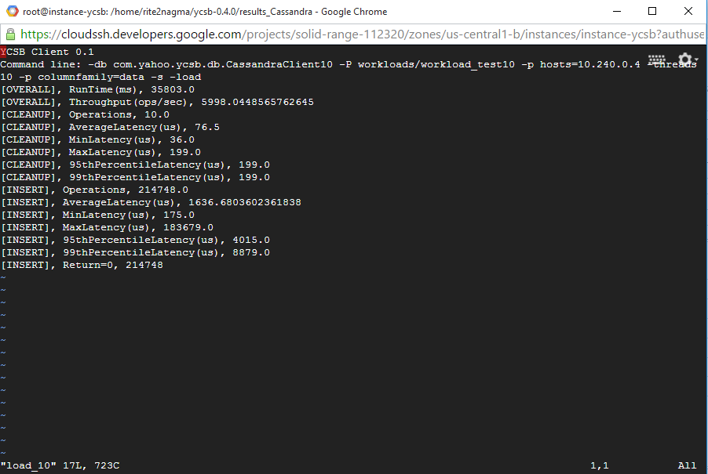

**10. Run benchmark for 10 concurrent users**

./bin/ycsb run cassandra-10 -P workloads/workload_test10 -p hosts=10.240.0.4 -threads 10 -p columnfamily=data -s > results_Cassandra/run_10

**Run_10 file generated:**

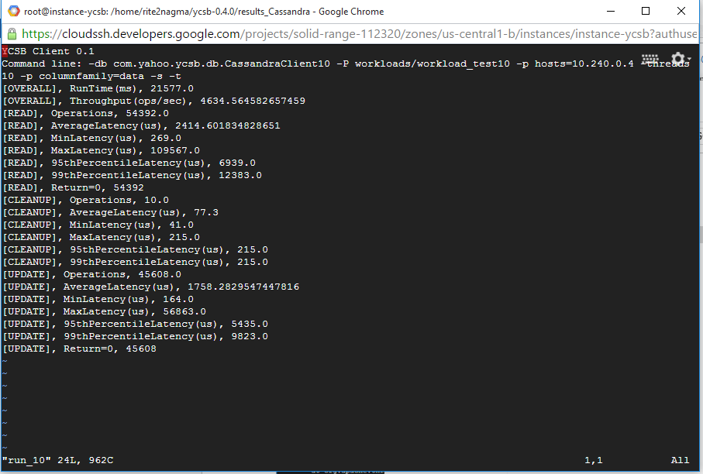

*Note:*

*Check your IP address*

**Clean loaded data for next benchmark**

drop table usertable.data;  
CREATE TABLE usertable.data ( key blob, column1 text, value blob, PRIMARY KEY (key, column1)) WITH COMPACT STORAGE AND CLUSTERING ORDER BY (column1 ASC);

**Repeat benchmark with different configurations.**

*//Note: benchmark for 40 concurrent users*

./bin/ycsb load cassandra-10 -P workloads/workload_test40 -p hosts=10.240.0.4 -threads 40 -p columnfamily=data -s > results_Cassandra/load_40

**Load_40 file generated:**

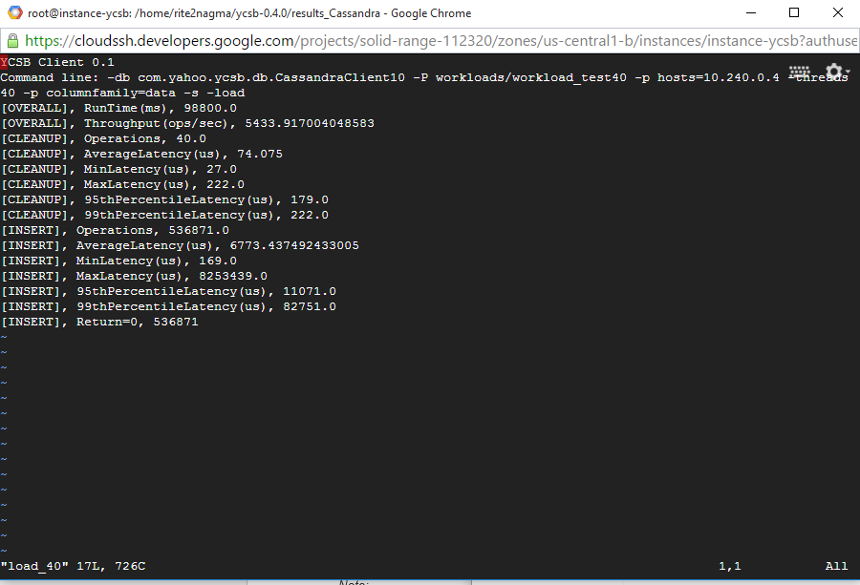

./bin/ycsb run cassandra-10 -P workloads/workload_test40 -p hosts=10.240.0.4 -threads 40 -p columnfamily=data -s > results_Cassandra/run_40

**Run_40 file generated:**

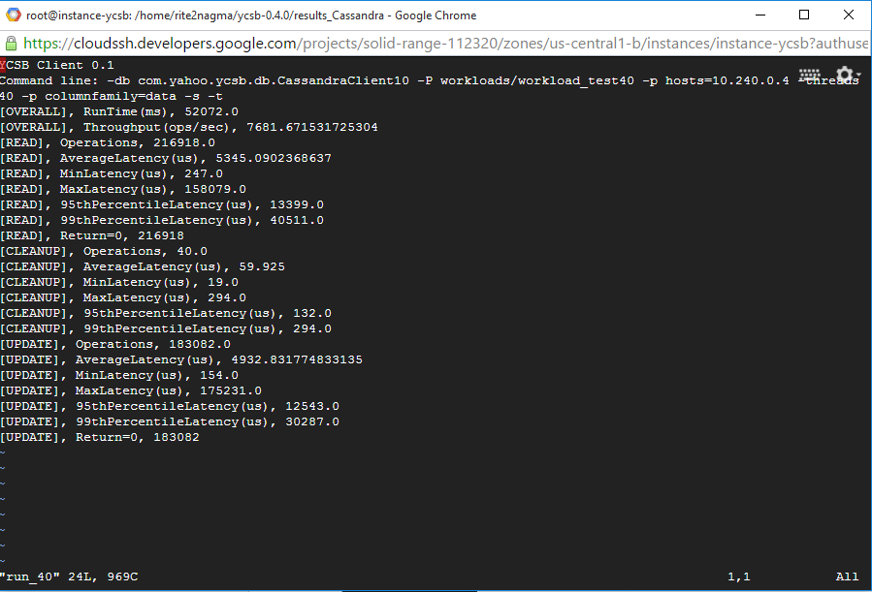

drop table data;  
CREATE TABLE usertable.data ( key blob, column1 text, value blob, PRIMARY KEY (key, column1)) WITH COMPACT STORAGE AND CLUSTERING ORDER BY (column1 ASC);

*//Note: benchmark for 320 concurrent users*

./bin/ycsb load cassandra-10 -P workloads/workload_test320 -p hosts=10.240.0.4 -threads 320 -p columnfamily=data -s > results_Cassandra/load_320

**Load_320 file generated:**

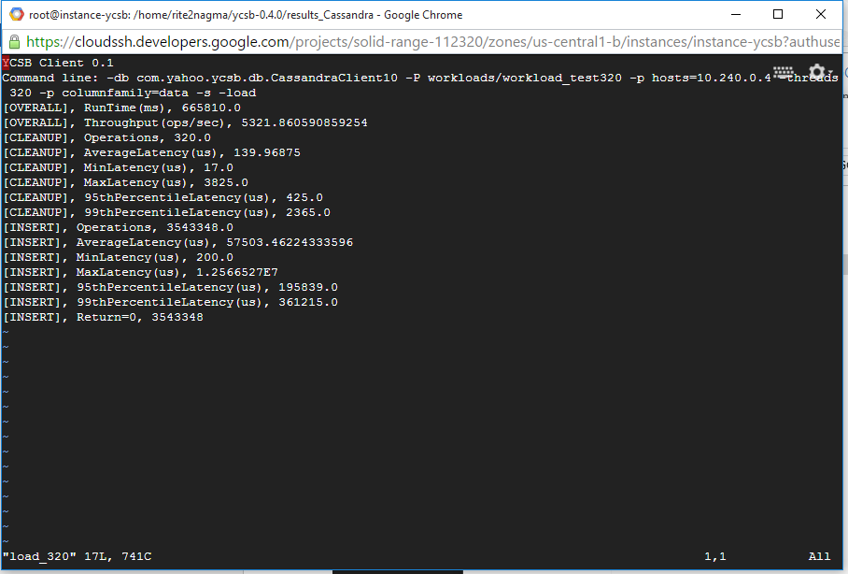

./bin/ycsb run cassandra-10 -P workloads/workload_test320 -p hosts=10.240.0.4 -threads 320 -p columnfamily=data -s > results_Cassandra/run_320

**Run_320 file generated:**

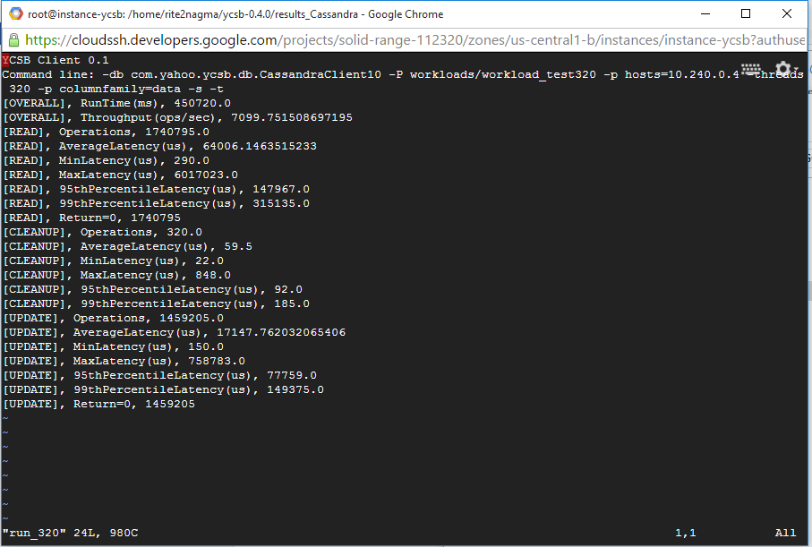

drop table data;  
CREATE TABLE usertable.data ( key blob, column1 text, value blob, PRIMARY KEY (key, column1)) WITH COMPACT STORAGE AND CLUSTERING ORDER BY (column1 ASC);

*//Note: benchmark for 640 concurrent users*

./bin/ycsb load cassandra-10 -P workloads/workload_test640 -p hosts=10.240.0.4 -threads 640 -p columnfamily=data -s > results_Cassandra/load_640

**Load 640 taking long time to run, so we cancel the process.**

**VM Instance specification:**

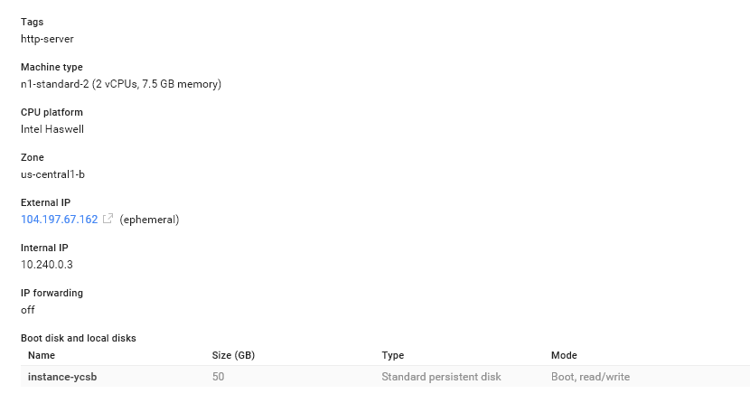

**Machine type:** n1-standard-2 (2 vCPUs, 7.5 GB memory)

**Boot disk and local disks:** 50GB

**Price: $51.10 per month for 1 node**

**$153.30 per month for 3 nodes**

